NANDHA ENGINEERING COLLEGE(AUTONOMOUS)
DEPARTMENT OF COMPUTER SCIENCE
OBJECT ORIENTED SOFTWARE ENGINEERING LABORATORY
NAME: NANDHITHA K
REG NO: 732224CS131
CLASS: CSE C
EX 1: PASSPORT AUTOMATION SYSTEM
1.CLASS DIAGRAM:
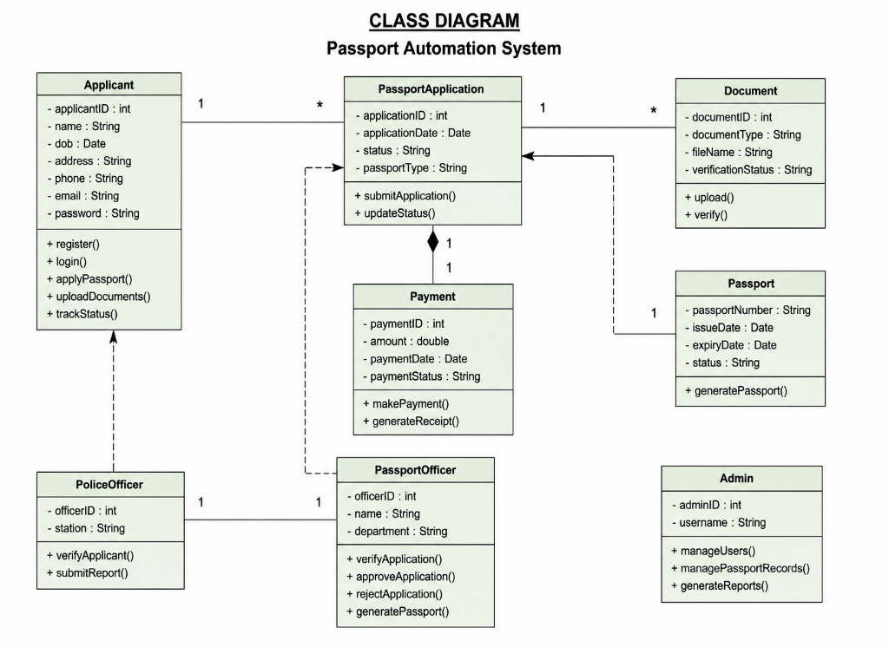
2. USECASE DIAGRAM:
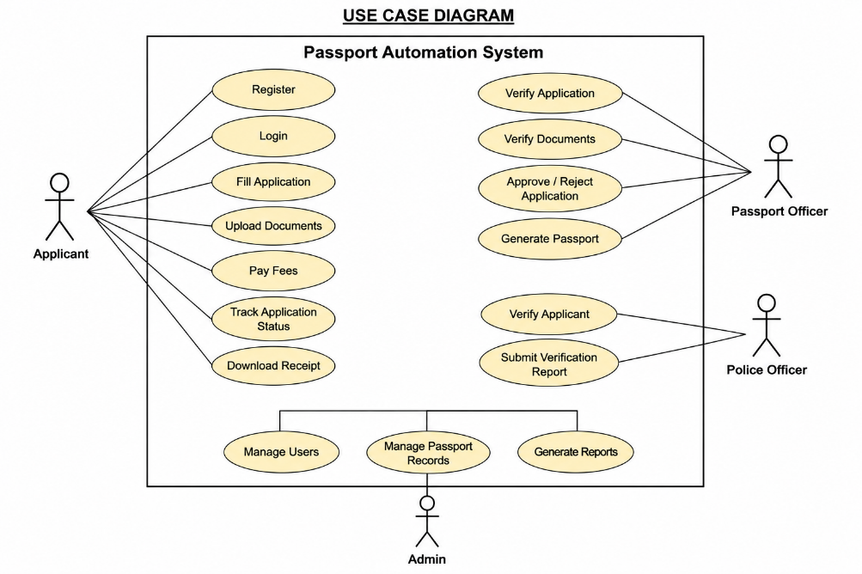
3. ACTIVITY DIAGRAM:
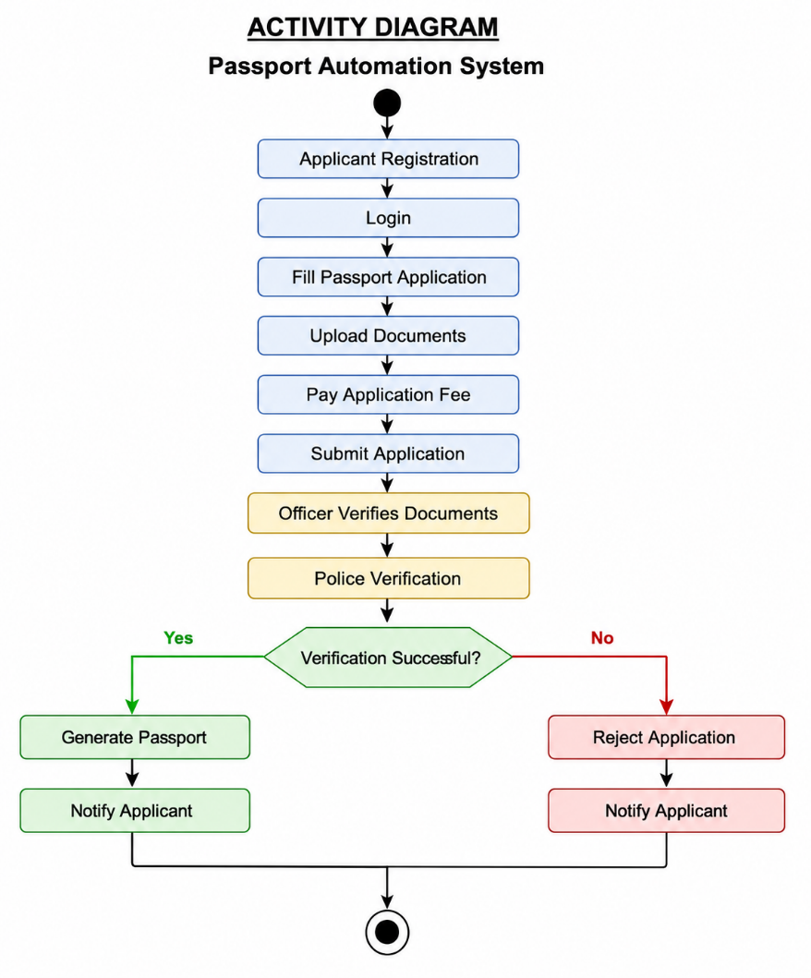
4.SEQUENCE DIAGRAM:
